Computer Science in School Library Media

Lesson Title: Agent Lion: ScratchJr_K-2
What is the source of this lesson? Ann Mengel, School Library Media Specialist, Caroline County
Relevant Link to original lesson (if applicable or N/A if not):
Grade (or Grade Range): K-2
Duration: 1 class (45 minutes - 1 hour)
Standards:
MD School Library
IV.B.4. Organizing information by priority, topic, or other systematic scheme.

MD Computer Science
K.AP.C.01 With guidance, create a set of instructions to accomplish a task using a programming language, device, or unplugged activity, including sequencing, emphasizing the beginning, middle, and end.
1:AP.C.01. With guidance, create programs by using creative expression or problem solving to accomplish tasks that include sequencing and repetition.
2.AP.C.01. Create programs using a programming language, robot, device, or unplugged activity that utilize sequencing and repetition to solve a problem or express creative ideas.

MD Digital Learning Standards for Students
Creative Communicator: 6b. Students create original works or responsibly repurpose or remix digital resources into new creations.
Objectives
Students will be able to use ScratchJr to show the beginning, middle and end of a story.

Essential Question(s)/Essential Skill(s):
How can we retell a story using a ScratchJr?
Materials:
- Agent Lion by David Bowman and Jack Davis
- Individual student access to ScratchJr
- Google Slideshow lesson plan
- sequence chain graphic organizer

Procedures:
- Discuss today’s objectives and topic of story structure: beginning, middle and end.
- Show students the front cover of Agent Lion. Ask, “What do you think will happen in the story?”
- Read the story Agent Lion or any story with a clearly defined plot: beginning, middle and end.
- Complete the sequence chain graphic organizer. You may decide to do this as a class or print this out and have students draw or write each section with partners or individually.
- Use ScratchJr to retell the story. Include 3 backgrounds to represent the beginning, middle, and end of the book. Draw or modify characters in Scratch Jr to represent characters in the book. Introduce the Say block to create dialogue among the characters. Use any combination of triggering, motion, looks, sound, control, and end blocks to make your events interactive.
- Resources on ScratchJr.
  - Scratch Interface Guide
  - Paint Editor Guide
  - Block Descriptions
  - Scratch Tips and Hints
- Gallery Walk: Students walk around and view others’ coded creations. When finished, ask “What did you learn today? What went well? What was hard to figure out?” Discuss.

***NEW BLOCK! This block ends this backdrop’s code and automatically goes to the next page (backdrop) and starts the code if the event block is the Start on FLAG.

***NOTE: This could be used with any book that has a clearly defined plot for beginning, middle, and end. Agent Lion is just the book used for this example.

Example of code:
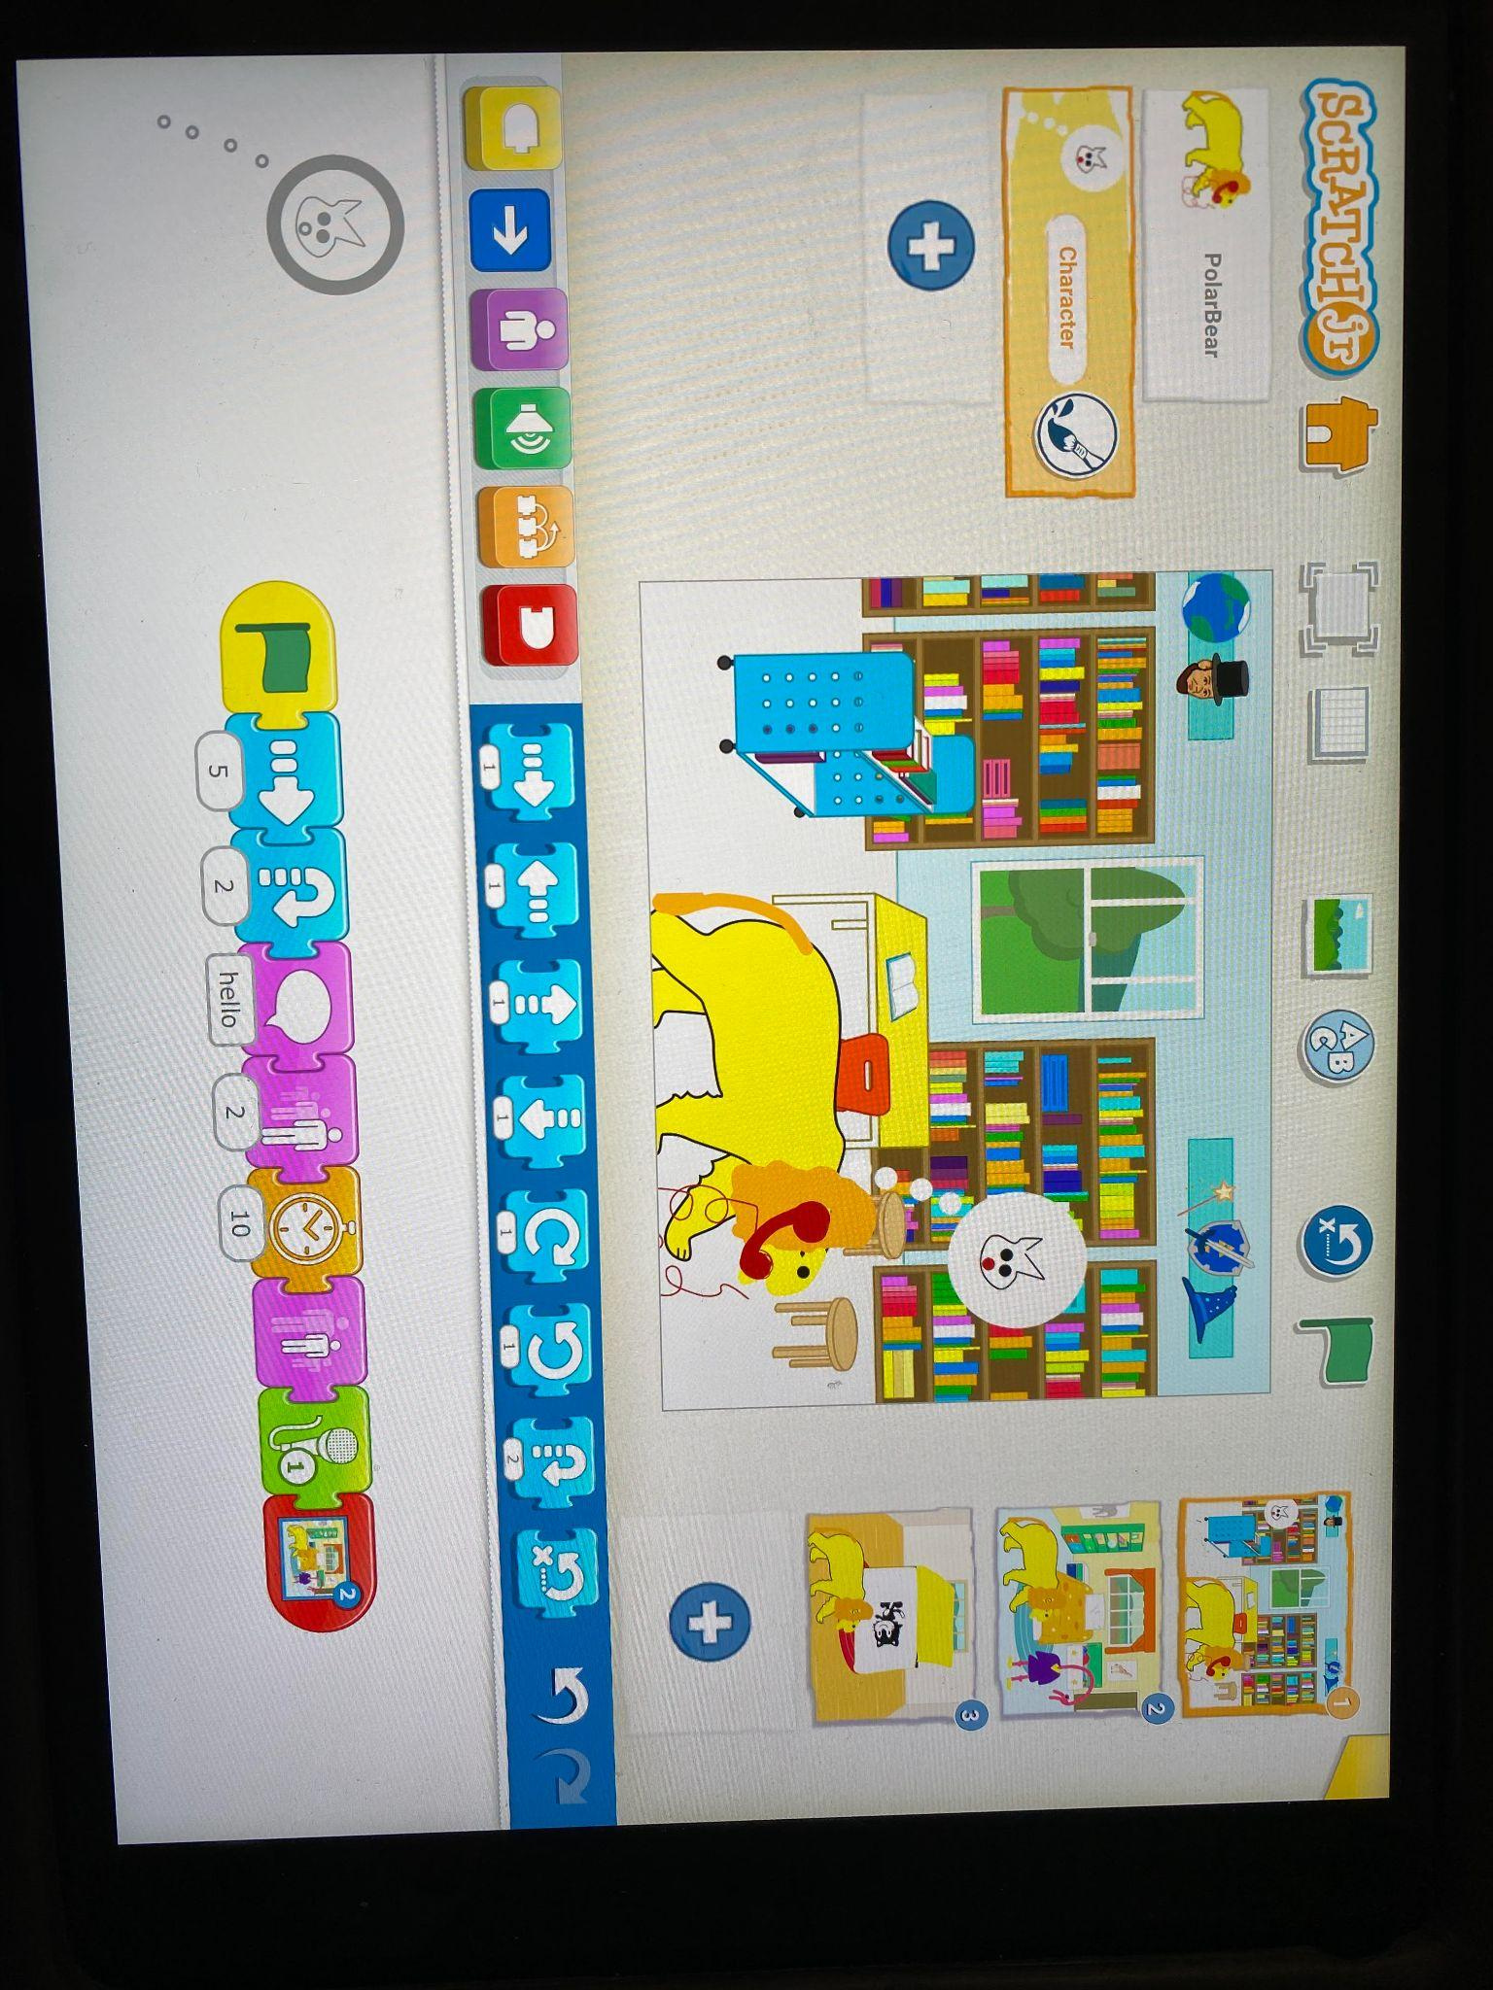
Your Name: Modified by Brittainy Simmons

